Cumbria Archives: Copyright Declaration

If you are requesting or taking digital copies of documents or microforms, you will be asked to complete this copyright declaration. We will be unable to supply you with the copies you require until payment and a completed form has been received.

DECLARATION

I declare that in ordering or taking copies:

- I have not previously been supplied with a copy of the same material by you or any other archivist or librarian.
- I will not use the images or copies except for non-commercial research or private study and will not supply a copy of it to any other person.
- FOR UNPUBLISHED MATERIAL ONLY: To the best of my knowledge the work has not been published before the document was deposited with Cumbria Archives and the copyright owner has not prohibited copying of the work.
- FOR PUBLISHED MATERIAL ONLY: To the best of my knowledge no other person with whom I work or study has made or intends to make, at or about the same time as this request, a request for substantially the same material for substantially the same purpose.
- I declare that the image or photocopy will not be altered, transmitted or mounted on the internet (including social media) or an intranet, and that it will not be further copied.
- I understand that if this declaration is false in a material particular the image made by me or the copy supplied to me by you will be an infringing copy and that I shall be liable for infringement of copyright as if I had made the copy myself.

Name…………………………………….. Signature*……………………………………..
Address………………………………….. (* Signature can be word-processed)
……………………………………………
Date……………………………………………
……………………………………………..
Phone No………………………………… E-mail …………………………………………..

IMPORTANT NOTE
Not all archives are in copyright (in which case the terms set out above will not apply) but this declaration must be signed as a precautionary measure.

Both original records and printed books are protected by copyright. In accordance with the terms of Copyright, Designs and Patents Act 1988, the Copyright and Related Rights Regulations 2003, and the Copyright and Rights in Performances (Research, Education, Libraries and Archives) Regulations 2014, Cumbria Archives can only supply one copy of an item in copyright and a ‘reasonable amount’ (normally up to 5%) of a published work in copyright for ‘fair dealing’ purposes and only for private and non-commercial research. If you wish to reproduce or publish material in copyright then you must obtain permission from both the owner of the copyright and also (in the case of original records) from the owner of the record. Please ask staff for further advice.

If you publish records, you should acknowledge the Archive Centre and quote the reference of the document. The correct titles of the Archive Centres are: Cumbria Archive Centre (Barrow), Cumbria Archive Centre (Carlisle), Cumbria Archive Centre (Kendal), Cumbria Archive and Local Studies Centre (Whitehaven).
There are a range of charges for publication and exhibition of documents depending on whether it is for local history or commercial use; please enquire for further details.

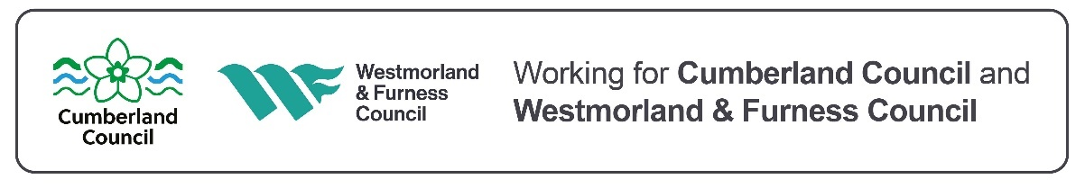

RECORD OF COPIES SUPPLIED
All charges for orders are calculated to include a cost for the time taken to locate and copy material, calculated on a pro rata basis of £62 per hour to include postage and packing. The minimum charge for orders will be £15.50 for 1- 10 copies.

Purchase the appropriate number of copy units as requested by our staff from our online shop at
https://cumbriaarchives.org.uk/archives/onlineshop/default.asp
Document reference:
Description of document:

FOR STAFF USE only

CHARGES
COPIES _______________________
_______________________
DURATION OF JOB _______________________
COST OF STAFF TIME _______________________
TOTAL COST _______________________

DATE COMPLETED _______________________
INVOICE SENT _______________________

JOB NO. _______________________
MONEY RECEIVED _______________________
COPIES SENT _______________________
CHARGES
Charges for standard digital copies and Specialist Digitisation service (larger/more complex orders):
1 - 10 copies: £15.50
11 - 50 copies: £31
51- 100 copies: £62
work above 100 copies will be charged at the rates above (101-110 copies etc).
22 March 2024

